**Report for EE260 Lab 1: Perception**

1. Introduction

This lab focuses on using an ML model to detect objects and display bounding boxes around objects.

2. Environment Setup

Run the Carla server, generate back ground traffic and run automatic_control.py

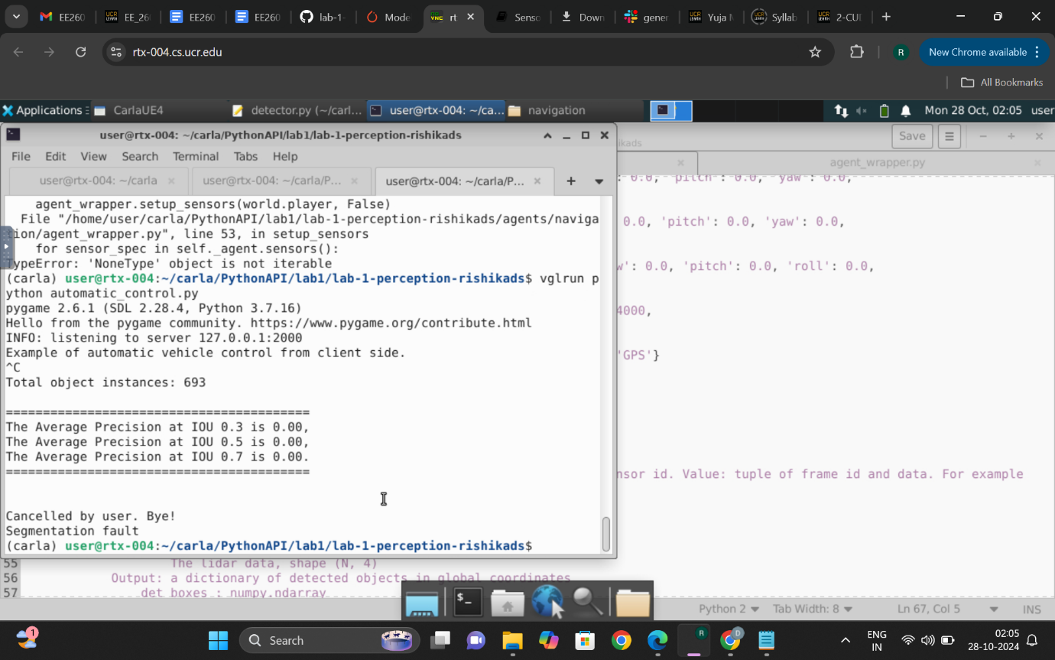

The ego vehicle crashes with other vehicles, and this output is obtained.

3. Sensor Setup and Visualization

Four sensors were set up- Three RGBs on the left, right and centre and one lidar on the top.

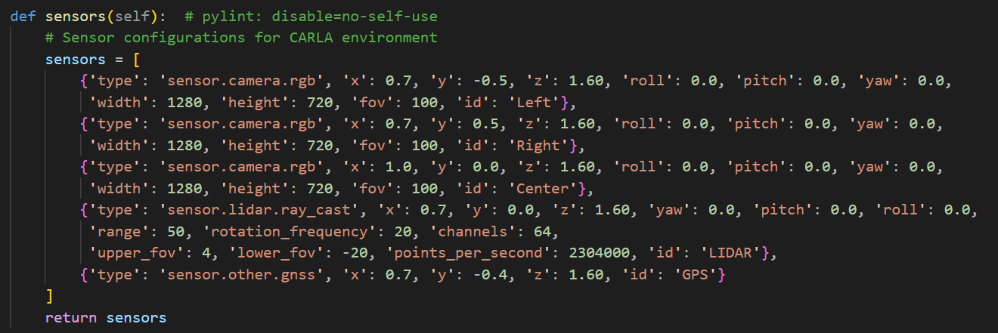

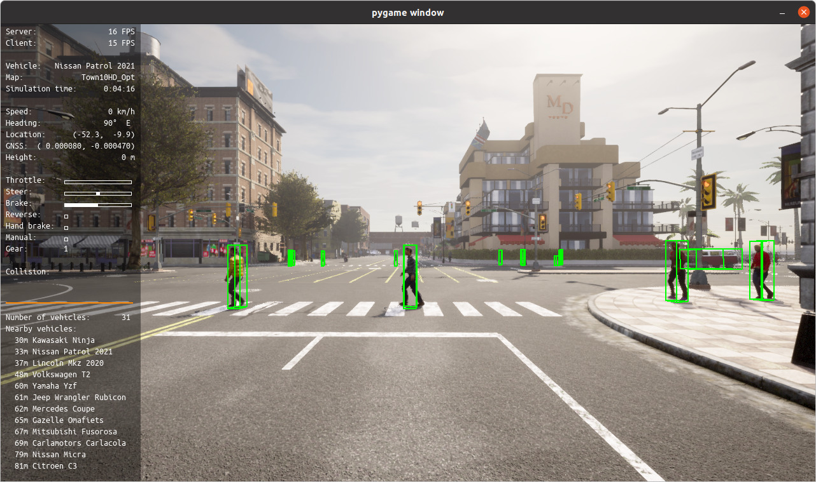

RGB centre camera visualization.

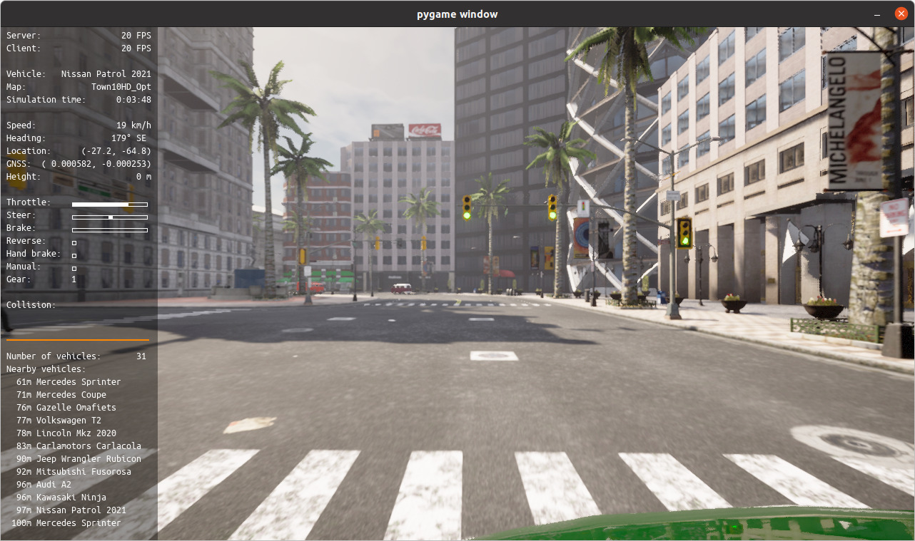

RGB left camera visualization.

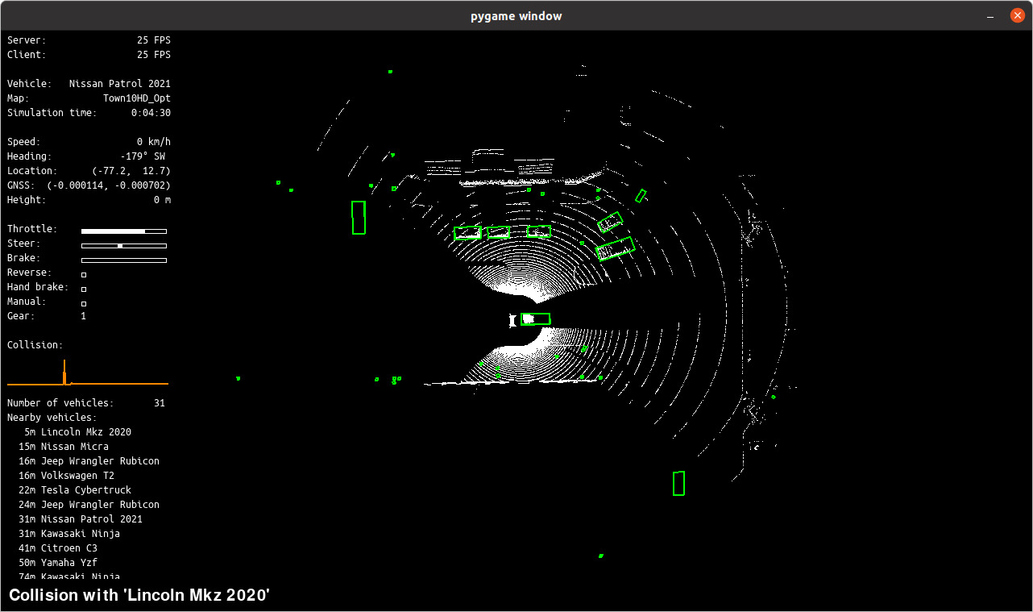

Lidar Visualization

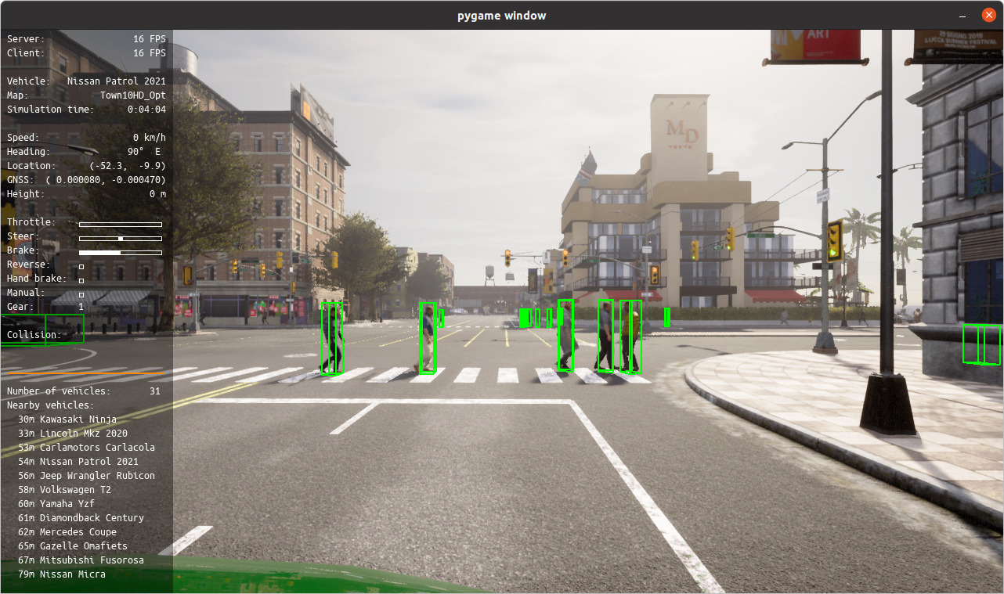

RGB right camera visualization.

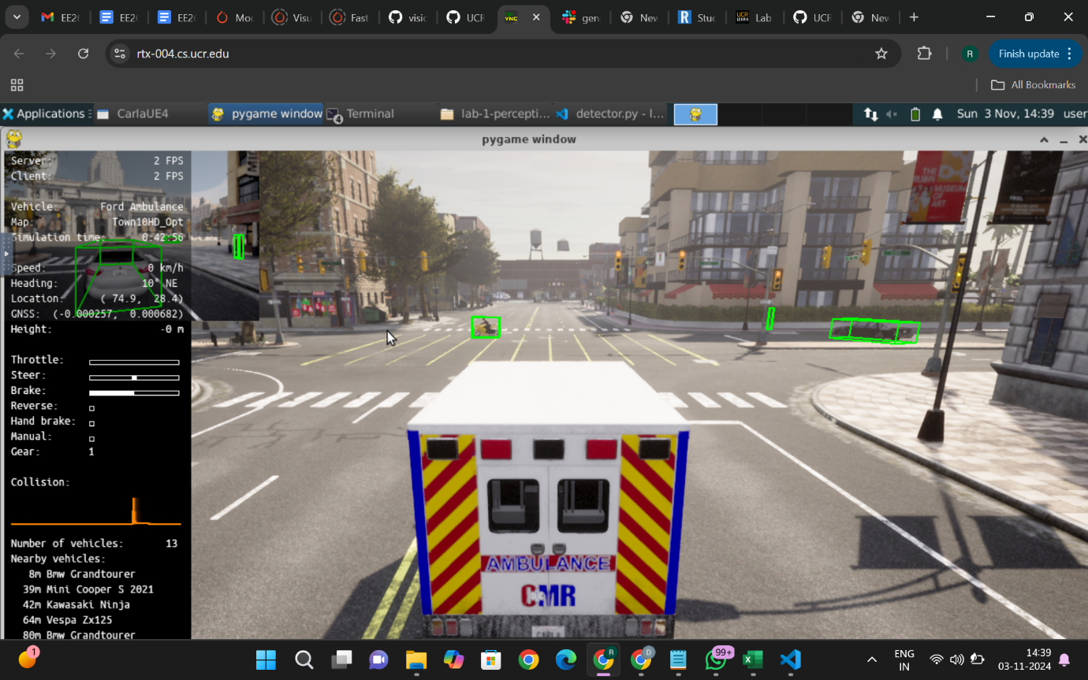

Visualizing the ground truth bounding boxes for traffic participants.

4. Integration of Pre-trained Perception Model

Pytorch Faster RCNN model was used for detection. The bounding boxes did appear in red, but there was some problem with the ground truth boxes.

The det_bbox dimentions and the gt_bbox dimentions were obtained, but they werent visualized(still working on it).

5. Performance Evaluation-

AP value is still appearing as 0 (working on it).

Output obtained during the AP value calculation-

Warning: gt_bbox is None or has insufficient dimensions.

gt_bbox: []

det_bbox: [[[640.06115723 329.14395142 0. ]

[648.39172363 329.14395142 0. ]

[648.39172363 343.85025024 0. ]

[640.06115723 343.85025024 0. ]

[640.06115723 329.14395142 1. ]

[648.39172363 329.14395142 1. ]

[648.39172363 343.85025024 1. ]

[640.06115723 343.85025024 1. ]]

[[599.30639648 328.8208313 0. ]

[605.98724365 328.8208313 0. ]

[605.98724365 339.68554688 0. ]

[599.30639648 339.68554688 0. ]

[599.30639648 328.8208313 1. ]

[605.98724365 328.8208313 1. ]

[605.98724365 339.68554688 1. ]

[599.30639648 339.68554688 1. ]]

[[378.95663452 447.9621582 0. ]

[393.25894165 447.9621582 0. ]

[393.25894165 480.6477356 0. ]

[378.95663452 480.6477356 0. ]

[378.95663452 447.9621582 1. ]

[393.25894165 447.9621582 1. ]

[393.25894165 480.6477356 1. ]

[378.95663452 480.6477356 1. ]]

[[848.36761475 270.81225586 0. ]

[882.88995361 270.81225586 0. ]

[882.88995361 377.6456604 0. ]

[848.36761475 377.6456604 0. ]

[848.36761475 270.81225586 1. ]

[882.88995361 270.81225586 1. ]

[882.88995361 377.6456604 1. ]

[848.36761475 377.6456604 1. ]]

[[148.01280212 339.90292358 0. ]

[228.59712219 339.90292358 0. ]

[228.59712219 370.71331787 0. ]

[148.01280212 370.71331787 0. ]

[148.01280212 339.90292358 1. ]

[228.59712219 339.90292358 1. ]

[228.59712219 370.71331787 1. ]

[148.01280212 370.71331787 1. ]]

[[675.55615234 322.78875732 0. ]

[687.00799561 322.78875732 0. ]

[687.00799561 352.60324097 0. ]

[675.55615234 352.60324097 0. ]

[675.55615234 322.78875732 1. ]

[687.00799561 322.78875732 1. ]

[687.00799561 352.60324097 1. ]

[675.55615234 352.60324097 1. ]]

[[ 55.69668961 506.96105957 0. ]

[ 75.93013 506.96105957 0. ]

[ 75.93013 552.48193359 0. ]

[ 55.69668961 552.48193359 0. ]

[ 55.69668961 506.96105957 1. ]

[ 75.93013 506.96105957 1. ]

[ 75.93013 552.48193359 1. ]

[ 55.69668961 552.48193359 1. ]]]

Warning: gt_bbox is None or has insufficient dimensions.

gt_bbox: []

det_bbox: [[[640.06115723 329.14395142 0. ]

[648.39172363 329.14395142 0. ]

[648.39172363 343.85025024 0. ]

[640.06115723 343.85025024 0. ]

[640.06115723 329.14395142 1. ]

[648.39172363 329.14395142 1. ]

[648.39172363 343.85025024 1. ]

[640.06115723 343.85025024 1. ]]

[[599.30639648 328.8208313 0. ]

[605.98724365 328.8208313 0. ]

[605.98724365 339.68554688 0. ]

[599.30639648 339.68554688 0. ]

[599.30639648 328.8208313 1. ]

[605.98724365 328.8208313 1. ]

[605.98724365 339.68554688 1. ]

[599.30639648 339.68554688 1. ]]

[[378.95663452 447.9621582 0. ]

[393.25894165 447.9621582 0. ]

[393.25894165 480.6477356 0. ]

[378.95663452 480.6477356 0. ]

[378.95663452 447.9621582 1. ]

[393.25894165 447.9621582 1. ]

[393.25894165 480.6477356 1. ]

[378.95663452 480.6477356 1. ]]

[[848.36761475 270.81225586 0. ]

[882.88995361 270.81225586 0. ]

[882.88995361 377.6456604 0. ]

[848.36761475 377.6456604 0. ]

[848.36761475 270.81225586 1. ]

[882.88995361 270.81225586 1. ]

[882.88995361 377.6456604 1. ]

[848.36761475 377.6456604 1. ]]

[[148.01280212 339.90292358 0. ]

[228.59712219 339.90292358 0. ]

[228.59712219 370.71331787 0. ]

[148.01280212 370.71331787 0. ]

[148.01280212 339.90292358 1. ]

[228.59712219 339.90292358 1. ]

[228.59712219 370.71331787 1. ]

[148.01280212 370.71331787 1. ]]

[[675.55615234 322.78875732 0. ]

[687.00799561 322.78875732 0. ]

[687.00799561 352.60324097 0. ]

[675.55615234 352.60324097 0. ]

[675.55615234 322.78875732 1. ]

[687.00799561 322.78875732 1. ]

[687.00799561 352.60324097 1. ]

[675.55615234 352.60324097 1. ]]

[[ 55.69668961 506.96105957 0. ]

[ 75.93013 506.96105957 0. ]

[ 75.93013 552.48193359 0. ]

[ 55.69668961 552.48193359 0. ]

[ 55.69668961 506.96105957 1. ]

[ 75.93013 506.96105957 1. ]

[ 75.93013 552.48193359 1. ]

[ 55.69668961 552.48193359 1. ]]]

Warning: gt_bbox is None or has insufficient dimensions.

gt_bbox: []

Fatal Python error: This thread state must be current when releasing

Thread 0x00007fe1d61b1700 (most recent call first):

Current thread 0x00007fe11e7fc700 (most recent call first):

File "automatic_control.py", line 823 in _parse_image

File "automatic_control.py", line 700 in <lambda>

Thread 0x00007fe206f91740 (most recent call first):

Aborted (core dumped)

7. Conclusion

Overall, a pretrained detection module was implemented and visualization results were obtained.